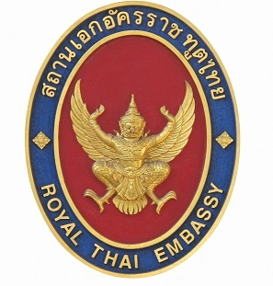
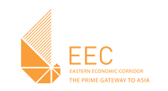


On the occasion of the visit of
the Eastern Economic Corridor Office of Thailand and
a high-level business delegation from Thailand
to the Hannover Fair 2019,
The Royal Thai Embassy Berlin,
the Eastern Economic Corridor Office of Thailand and
the OAV - German Asia-Pacific Business Association
have the honor to invite you to the

Thailand Business Network @ Hannover Messe 2019
On Tuesday, 2nd April 2019, 13.30 – 17.00 hrs
Room 18 (Conference Level), Convention Center, Hannover Fair


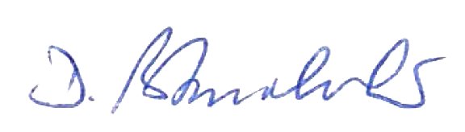
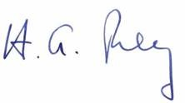

Dr. Dhiravat Bhumichitr

Ambassador of the Kingdom of Thailand to the Federal Republic of Germany
Mr. Hans-Georg Frey

Chairman of OAV -
German Asia-Pacific Business Association
Mr. Kanit Sangsubhan

Secretary-General
Eastern Economic Corridor Office of Thailand
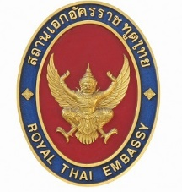


- Program -
Thailand Business Network @ Hannover Messe 2019
Tuesday, 2nd April 2019, 13.30 – 17.00 hrs.
13.30  (15 min) | Guests Welcoming
13.45 – 13.55  (10 min) | Welcoming Remarks  : Mr. Dhiravat Bhumichitr,  Ambassador of Thailand to the Federal Republic of Germany  : Mr. Stefan Messer, CEO, the Messer Group Co., Ltd. and Board Member and Chair of ASEAN Section, German Asia-Pacific Business Association (Ostasiatischer Verein e.V.: OAV)
13.55 – 14.10  (15 min) | Introductory Remarks  : Dr. Luxmon Attapich, Deputy Secretary-General, Eastern Economic Corridor Office (Thailand)
14.10 – 15.00  (50 min) | Panel Discussion I: Thailand’s Industry 4.0 - The Way Forward  [Panelists]:  Mr. Markus Lorenzini, President and CEO, Siemens Co., Ltd. (Thailand)  Mr. Techa Bunyachai, Vice Chairman, Thai Federation on Logistics  Mr. Sakda Sarapatwittaya, Board Committee of Thai Automation and Robotics Association (TARA)  Dr. Roland Wein, Executive Director, German-Thai Chamber of Commerce (GTCC)  Prof. Dr. Bernd Bachert, CEO, IRATEC, Co., Ltd. (Thailand)  [Moderator]:  Dr. Luxmon Attapich, Deputy Secretary-General, Eastern Economic Corridor Office
15.00 – 15.15  (15 min) | Q&A
15.15 – 16.05  (50 min) | Panel Discussion II: Creating Innovation Partnership for the Future - Opportunities & Challenges  [Panelists]:  Dr. Sarasin Viraphol, Executive Vice President, CP Group (Thailand)  Mr. Steffen Hessel, Regional Head, External Affairs and Government Relations,  Robert Bosch (SEA) Pte Ltd.  Mr. Franck-Olivier Rossignolle, CEO, Transdev Asia (France)  Mr. Robert Huber, Chair, Foreign Trade Committee, IHK Karlsruhe  Representative from Airbus Group, Inc.  [Moderator]:  Mrs. Nongnuth Phetcharatana, Special Advisor, Eastern Economic Corridor Office
16.05 – 16.20  (15 min) | Q&A
16.20 -17.00  (40 min) | Networking Reception  Participating Companies/Associations: Airbus Group, Inc., CP Group (Thailand), Elektronik und Informationstechnik (VDI), German Asia-Pacific Business Association (OAV), German-Thai Chamber of Commerce (GTCC), IHK Karlsruhe, IRATEC, Co., Ltd., Messer Group Co., Ltd., Robert Bosch (SEA) Pte Ltd., SCG (Thailand), Siemens Co., Ltd. (Thailand), Thai Automation and Robotic Association (TARA), Thai Federation on Logistics, ThyssenKrupp (Germany), Transdev Asia (France), TropicalTech Co., Ltd. (Thailand), Voith Group (Germany)
Room 18 (Conference Level), Convention Center, Hannover Fair
Reply form

Name …………………………………………………..……………………………….………………

__ I will attend the event

__ I will not attend the event

Company / organisation……………………………………………………….………………

Position………………………………………………………………………………….………

E-Mail…………………………………………………………………………….………………

Telephone……………………………………………………………………………….………

Please return the reply form by fax to 030 794 811 18
or e-mail to general@thaiembassy.de

or


follow the link to register online

https://docs.google.com/forms/d/1wBqd2IoU11S6zjBWG4i4TOyE_IjbM6O7LtPffQWdpbs

For further information please contact
Mr. Theeraphat Trangkathumkul
Royal Thai Embassy Berlin
Lepsiusstrasse 64/66, 12163
Email: theeraphatt@thaiembassy.de
Telephone: 01622099402

